Midterm I
Answer all the questions below. The exam is worth 100 points.

- (20 points) A statistician employed by a television rating service wanted to determine if there were differences in television viewing habits among three different cities in California. She took a random sample of five adults in each of the cities and asked each to report the number of hours spent watching television in the previous week. The results are shown below. (Assume normal distributions with equal variances.)

Hours Spent Watching Television
San Diego | Los Angeles | San Francisco
25 | 28 | 23
31 | 33 | 18
18 | 35 | 21
23 | 29 | 17
27 | 36 | 15

- Can she infer at the 5% significance level that differences in hours of television watching exist among the three cities?
- Use the LSD method (alpha=0.05) to assess which differences are significant.
- Apply the LSD method with the Bonferroni adjustment
- Repeat this comparison with Tuckey’s method (alpha=0.05).

Solution
Source of Variation | SS | df | MS | F | P-value | F critical
Treatments | 450.533 | 2 | 225.267 | 14.659 | 0.0006 | 3.885
Error | 184.400 | 12 | 15.367
Total | 634.933 | 14

Part a)
H₀: ₁ = ₂ = ₃
H₁: At least two means differ
F calculated is > than F tabulated hence we reject null hypothesis

Conclusion: from the data , there is a difference in mean hours of news in the television watching of at least two of the three cities,

Part b
Using LSD method
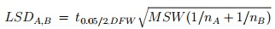
= 2.179$√15.367(\frac{1}{5}+\frac{1}{5})$
=5.4023
Y-bar=7
Hence 7>5.402 (LSD) hence we reject null hypothesis

- (10 points) In recent years the irradiation of food to reduce bacteria and preserve the food longer has become more common. A company that performs this service has developed four different methods of irradiating food. To determine which is best, it conducts an experiment where different foods are irradiated and the bacteria count is measured. As part of the experiment the following foods are irradiated: beef, chicken, turkey, eggs, and milk. The results are shown below.

 | Bacteria Count
Food | Method 1 | Method 2 | Method 3 | Method 4
Beef | 47 | 53 | 36 | 68
Chicken | 53 | 61 | 48 | 75
Turkey | 68 | 85 | 55 | 45
Eggs | 25 | 24 | 20 | 27
Milk | 44 | 48 | 38 | 46

- Can the company infer at the 1% significance level that differences in the bacteria count exist among the four irradiation methods?
- Can the company infer at the 1% significance level that differences in the bacteria count exist among the different types of food?

Solutions
The ANOVA Table of the above data will be as shown below using Use  = 0.01
ANS:
Source of Variation | SS | df | MS | F | P-value | F critical
Treatments | 650.2 | 3 | 216.733 | 2.033 | 0.1630 | 5.953
Blocks | 3838.7 | 4 | 959.675 | 9.002 | 0.0013 | 5.412
Error | 1279.3 | 12 | 106.608
Total | 5768.2 | 19
Part a
H₀: ₁ = ₂ = ₃ = ₄
vs.
H₁: At least two irradiation method differ
F-tab = F_{p-n-p}
F_{5, n-5}= 16.26
F- Calculated is less than F tabulated hence we fail to reject null hypothesis
Conclusion: From the Analysis of the given data, there is no any differences in the bacteria count that exist among the four irradiation methods, according to this data
Part b
H₀: ₁ = ₂ = ₃ = ₄ vs.
H₁: At least two food categories differ
F-tab = F_{p-n-p}
F_{5, n-5}= 16.26 from the f tables
F- Calculated is less than F tabulated hence we fail to reject null hypothesis
Conclusion: From the Analysis of the given data, there is no any differences in food type that exist among the four irradiation methods, according to this data

- (20 points) The data shown here were taken from a 2x3 factorial experiment with 4 replicates:
 | Factor B
Factor A | 1 | 2
1 | 23 | 20
 | 18 | 17
 | 17 | 16
 | 20 | 19
2 | 27 | 29
 | 23 | 23
 | 20 | 27
 | 28 | 25
3 | 23 | 27
 | 21 | 19
 | 24 | 20
 | 16 | 22
- Test at the 5% significance level to determine whether Factors A and B interact.
- Test at the 5% significance level to determine whether differences exist between the levels of factor A.
- Test at the 5% significance level to determine whether differences exist between the levels of factor B.
Solution
Factor coding using minitab (-1, 0, +1)

Anova
Source DF Adj SS Adj MS F-Value P-Value

A 2 17 7.250 88.6250 9.99 0.001

B 1 0.375 0.3750 0.04 0.839

A*B 2 9.250 4.6250 0.52 0.603

Error 18 159. 750 8.8750

Total 23 34 6.625
B Fixed 2 1 2

Part a)
F calculated (2,18)=0.5
P value=0.6 > 0.05 hence we reject null hypothesis and conclude that there is a difference between the level of factors A and B

Part b)
F calculated (2,18)= 9.9
And p value =<0.05 hence we reject Ho and conclude that there is interaction between the level of factors A and B

Part c)
F calculated (1,18)=0.04
P value=0.84 > 0.05 hence we reject null hypothesis and conclude that there is no difference between the level of factors A and B

- (10 points) In 2003, the student body of a state university in Michigan consists of 30% freshmen, 25% sophomores, 27% juniors, and 18% seniors. A sample of 400 students taken from the 2004 student body showed that there are 138 freshmen, 88 sophomores, 94 juniors, and 80 seniors. Test with 1% significance level to determine whether the student body proportions have changed.

Solution

 | Number of students | pi | ei
Freshmen | 138 | 0.3 | 120 | 2.7
Sophomores | 88 | 0.25 | 100 | 1.44
Juniors | 94 | .27 | 108 | 1.81
Seniors | 80 | 0.18 | 72 | .89
Totals | 400 | 1 | 400 | 6.84

Hypothesis:

Ho : The student body proportions NOT changed from their specified values 0 :
H1: At least two proportions differ from their specified values

(X²)Chi-Square test statistics Value is -6.843704
Chis-Square tabulated -7.8147

Conclusion, since Chi-square tabulated is greater than chi square calculated hence we fail to reject Ho and therefore we conclude that No students body proportions NOT changed from their specified values

- (20 points) The number of cars sold by three salespersons over a 3-month period is shown below:

 | Brand of Car
Salesperson | Brand A | Brand B | Brand C
David | 7 | 2 | 6
Edward | 11 | 4 | 8
Frank | 8 | 5 | 3

Use the 5% level of significance and test for the independence of salesperson and type of product sold.

Solutions
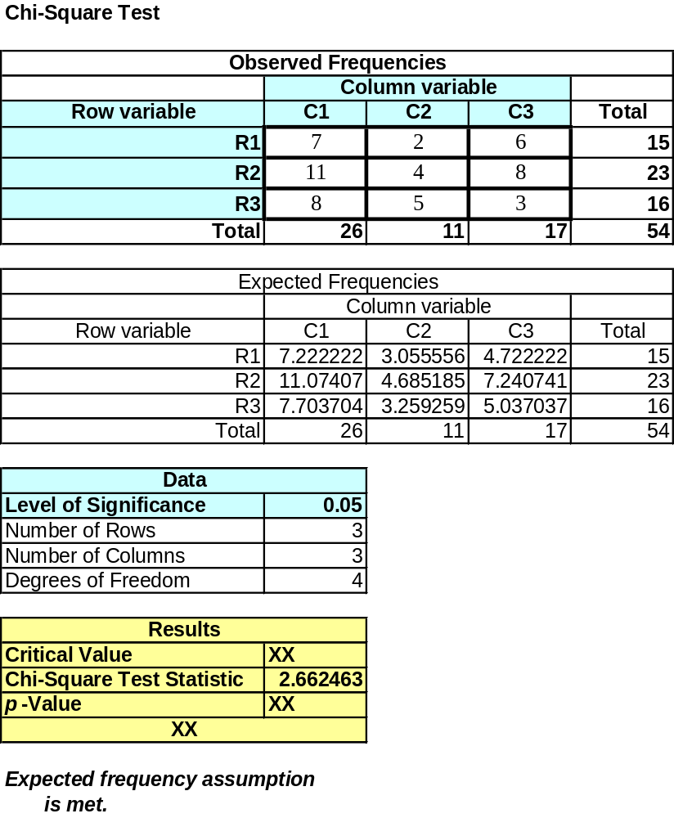

X²=(k-1)*(y-1) where k and y are degree of freedom
(3-1)(3-1)
=4 degree of freedom
From the Chi-square table = 9.488
Hence X²cal < X²tab hence we fail to reject the Ho and conclude that there is existence of independence of salesperson and type of product sold.

- (20 points) During the decade of the 1980s, professional Baseball thrived in North America (Sports.xls). However, in the 1990s attendance dropped, and the number of television viewers also decreased. To examine the popularity of baseball relative to other sports, surveys were performed. In 1985 and again in 1992, a Harris Poll asked a random sample of 500 people to name their favorite sport. The results, which were published in the Wall Street Journal (July 6, 1993), were recorded in the following way: favorite sport (1= professional football, 2= baseball, 3=professional basketball, 4= college basketball, 5= college football, 6= golf, 7= auto racing, 8= tennis, and 9= other)’ year: (1= 1985, 2=1992). Do these results indicate that North Americans changed their favorite sports between 1985 and 1992?

Solution
Using Minitab for data Analysis , the contingency table will be( From Minitab)
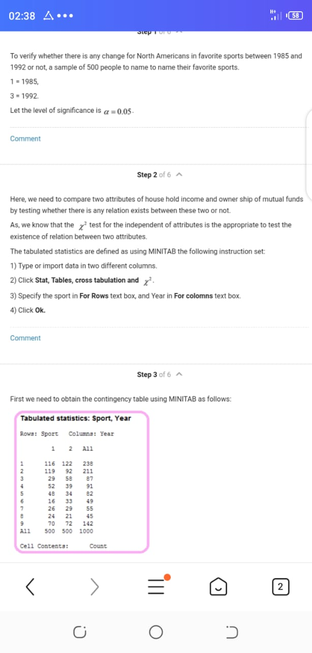
The output will be

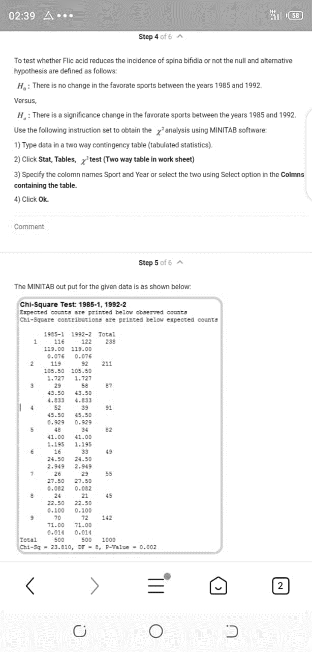

From the output the p value 0.002 is less than the level of significance 0.05 hence reject the Ho and conclude that the there is a significance change of sports between 1985-1992

